Tokenization

* 1. Making your own tokenizer (0.5 pt)

For this assignment, make a simple tokenizer. Write 3 sentences and try the tokenizer out on them. What to submit:

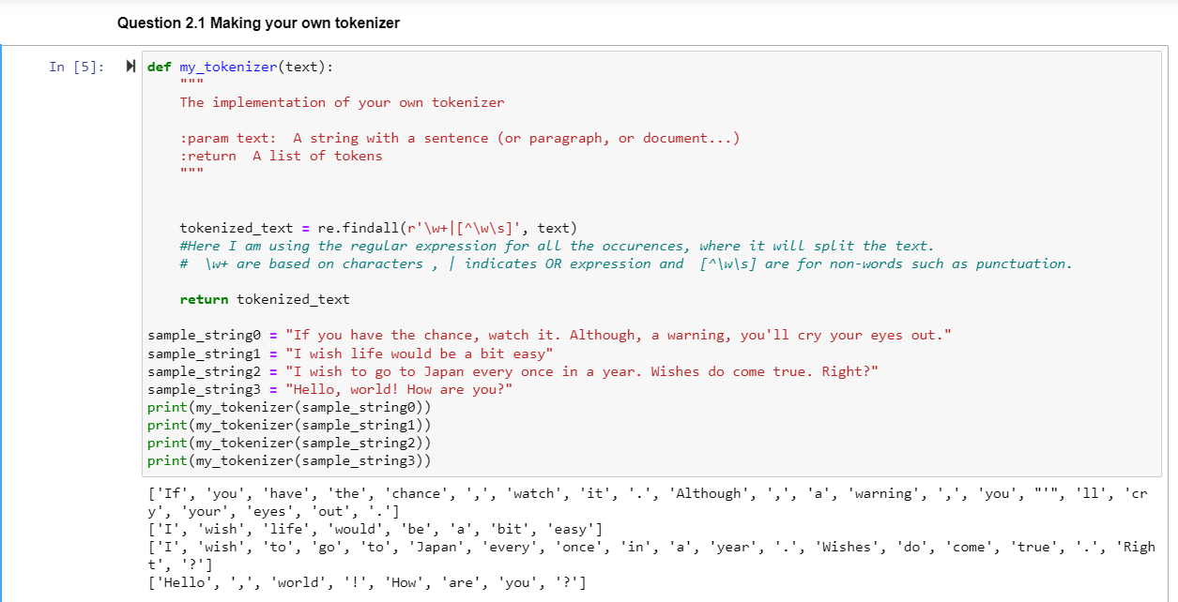

• Provide a description of how your tokenizer works.

From the above, we can see that tokenizer works quite well, it is tokenizing each words such as it tokenized you’ll into ‘you’ “ ’ “ ‘ll’ and tokenize the Symbols separately such as !, . , and ?.

• Report the tokens you obtain when using your tokenizer on your example sentences.

['If', 'you', 'have', 'the', 'chance', ',', 'watch', 'it', '.', 'Although', ',', 'a', 'warning', ',', 'you', "'", 'll', 'cry', 'your', 'eyes', 'out', '.']

['I', 'wish', 'life', 'would', 'be', 'a', 'bit', 'easy']

['I', 'wish', 'to', 'go', 'to', 'Japan', 'every', 'once', 'in', 'a', 'year', '.', 'Wishes', 'do', 'come', 'true', '.', 'Right', '?']

['Hello', ',', 'world', '!', 'How', 'are', 'you', '?']

# Using an off-the-shelf tokenizer (1 pt)

Compare the tokenizer you implemented in the previous question with one from NLTK, using the sentences provided in the Notebook.

What to submit: Reflect and answer these questions:

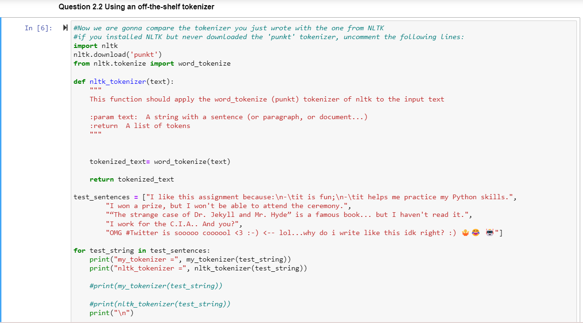

• What are the differences in the two tokenizer outputs?

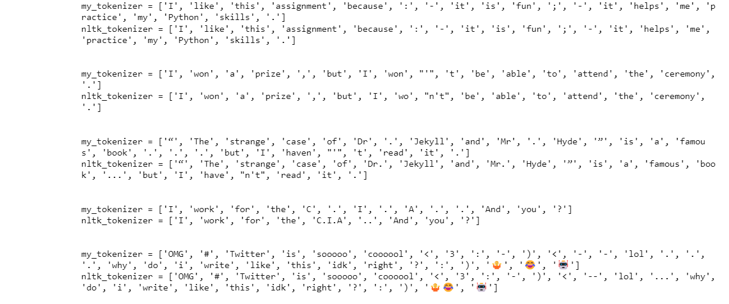

From above we can see :

1. There is not much difference when it comes to first sentence.
2. my_tokenizer tokenize won’t to ‘won’, “ ‘ “, ‘t’ whereas nltk_tokenizer tokenize to ‘wo’ , “n’t”.
3. my_tokenizer tokenize Dr.Jekyll to ‘Dr’, “ . “, ‘Jekyll’ whereas nltk_tokenizer tokenize to ‘Dr.’ , ‘Jekyll’ and same with Mr.Hyde. Furthermore, my_tokenizer tokenize … to ‘.’, “ . “, ‘.’ whereas nltk_tokenizer tokenize to ‘…’ and for haven’t my_tokenizer tokenize ‘haven’, “ ‘ “, ‘t’ whereas nltk_tokenizer tokenize to ‘have’ , ‘n’t’
4. my_tokenizer tokenize C.I.A to ‘C’ , “ . “, ‘I’ , “ . “, ‘A’ whereas nltk_tokenizer tokenize to ‘C.I.A’.
5. my_tokenizer tokenize every single emoji separately whereas nltk_tokenizer tokenize some together and some separately.

From this we can say my_tokenizer tokenize too much whereas nltk_tokenizer tokenize less.

• While coding your tokenizer, did you foresee all these inputs?

While coding our tokenizer, we did foresee all these inputs.

• Is there a single ‘perfect tokenizer’?

The efficiency of a tokenizer depends on the precise task, language, and text data being processed.it does vary across languages and scripts. The domain and the nature of the data also impact tokenization as tokenization on articles might be different from tokenization for social media text. There is no generally perfect tokenizer but rather a range of tokenization tools that can be selected and customized based on the requirements of a particular project.

# Text classification with a unigram language model

## Theory

What to submit:

• The probability of P(boring|Pos), using Laplace smoothing, showing the formula you used and intermediate calculations.

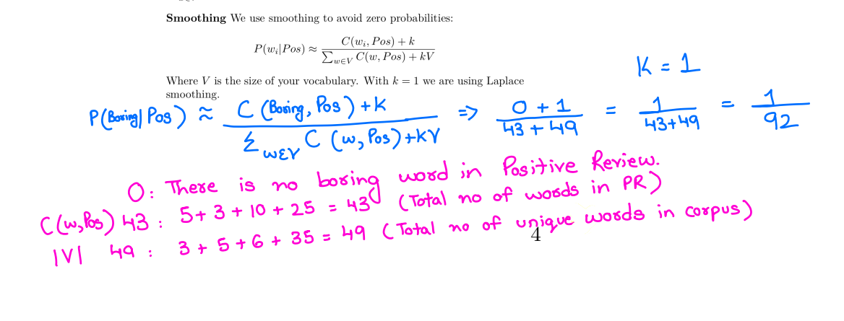

Would “intriguing yet disappointing” be classified as a positive or negative review? Why (show the probabilities used to decide it)?

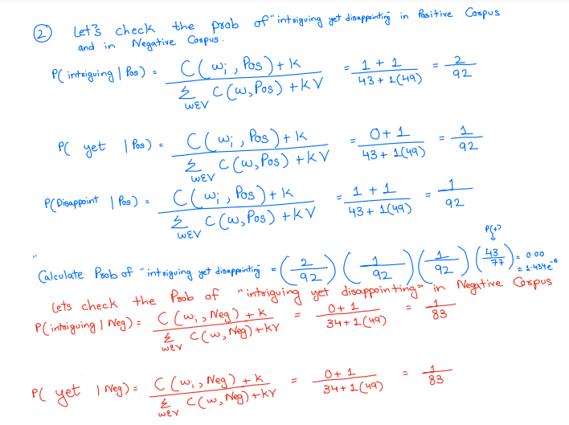

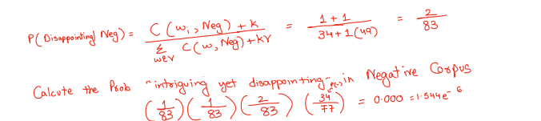

So, intriguing yet disappointing” is considered as Negative corpus.

##Here I added P(+) and P(-)

OR

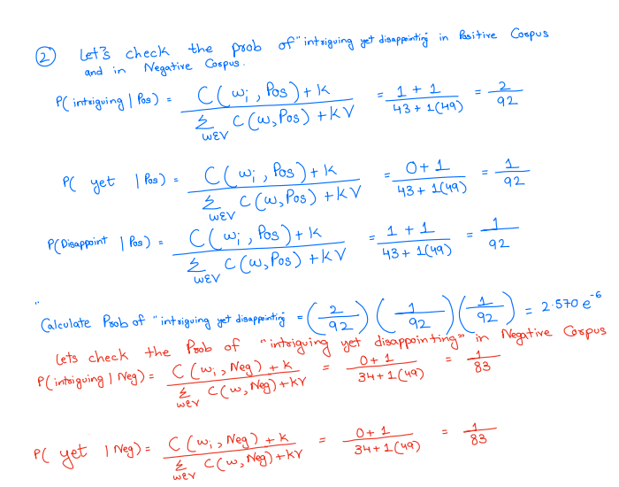

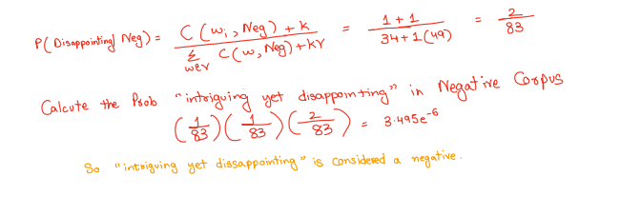

## Without P(-)

Kindly choose one

# Coding

1. The performance of your classifier (accuracy) when running with and without Laplace smoothing (k = 1 and k = 0 respectively).

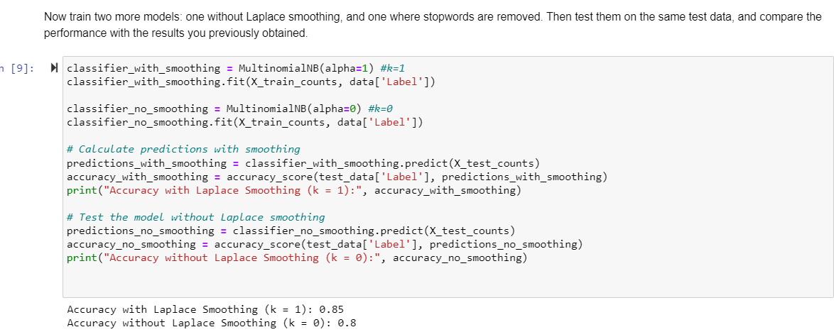

1. The performance removing stop words vs. without removing them. Are they different? Why is that? •

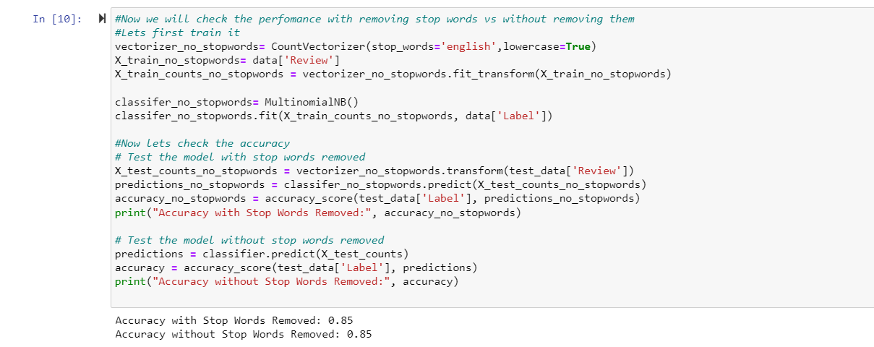

The accuracy with Stop Words removed and without stop words removed are the same which is 0.85. This means that the choice of removing stop words or doesn’t have a significant impact on the classification task for this specific dataset.

1. The performance after disabling the default lowercase normalization (and without stop word removal). Is there a difference, and if so, why do you think there is one?

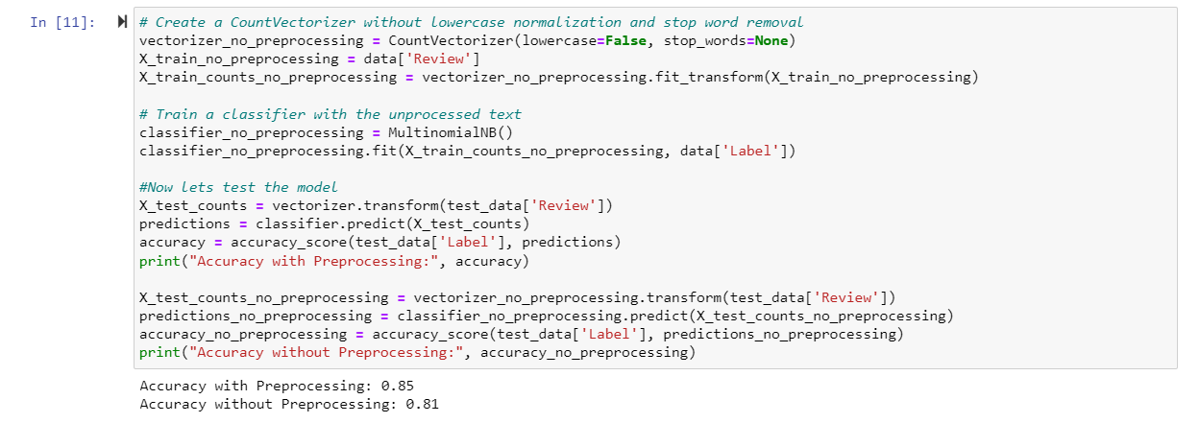

The accuracy with Preprocessing is 0.85 whereas, the accuracy without Preprocessing is 0.81. I think it is based on the characteristics of our data. If we look at the work of preprocessing phase, all texts are converted into lower case that means it has reduced the dimensionality of the feature space while in without preprocessing phase words in different case are considered different. Indeed, the lowercase normalization and stop word removal seems to have a positive impact on the models performance.